 | Target computer programmers and IT professionals at http://www.planet-source-code.com/ . Home of the net’s largest code database (over half a million lines!), it boasts a hyper engaged audience, and is the winner of numerous awards and honors!  Three Reasons You Should Advertise  Competitive Analysis  Demographics  Rates

Three Reasons to Advertise
on Planet Source Code
1) The 400-Pound Gorilla  Be seen on the biggest and best developer site on the net!  Dwarfing the others with over a million lines of code in all of the top programming languages (Visual Basic, Java, Javascript, C, C++, C#, Active Server Pages, Delphi, SQL Server and CGI/PERL)  Winner of numerous awards (Microsoft Developer Network Online Award, Netscape Open Directory: Cool Site, Best of the Planet: People's Choice Award, Starting Point Hot Site Award, Developer's Choice Top Site Award, Golden Web Award and many more) | 
 | 2) A Hyper-Engaged Audience  Studies show an engaged audience is a receptive audience. Planet Source Code’s viewers are hyper-engaged!  41% use the site for 60+ minutes at a time.  69% visit more than once a week.  More new submissions in a few days than its top competitor does in an entire month!

 |  | Competitive Analysis:  Top 3 Computer Programmer Sites on the Internet  (5/29/2000)
 | Content:  Planet Source Code is the undisputed leader in developer site content. Its database is heads and shoulders above the closest competition!
 | Planet Source Code.com |  | Free Code.com | Code Guru.com
Languages: | Visual Basic, C, C++, Java, Javascript, Active Server Pages, Perl, SQL, Delphi |  | C/C++, Java, Perl, Visual Basic | Visual Basic, C++, Java
Code broken out by language? | Yes |  | No | Yes
Number of Code Entries: | 16,023 |  | 811 | 1,929 (Most are 'links' to  other sites—a large # link to  Planet-Source-Code.com!
Community Activity:
Planet Source Code is where developers are going on a daily basis to post new code and interact with other developers. The other sites are not even close!
 | Planet Source Code.com |  | Free Code.com | Code Guru.com
Average new submissions/day | 24-37 / day |  | 0.3/day | 1-3 / day
Allows users to post questions/feedback on code? | Yes. Heavily used. Some submissions have more comments than code! |  | Yes, but it is completely empty | Yes, but comment area is completely  empty in Visual Basic area. Some  spotty participation in C++ area.
Author Friendly:
Code authors participate so much more on Planet Source Code than other sites because their input is warmly welcomed, and their participation earns them more rewards.
 | Planet Source Code.com |  | Free Code.com | Code Guru.com
Allows users to upload new code/articles? | Yes |  | No | Yes, but must be 'approved' by site.  Most submissions are never posted.
Publicity for author on each page with a personal profile and photo | Yes |  | No | No, only a link to email address.
Coding Contest for best code? | Yes. Prizes include recognition in the 'Hall of Fame' as well as free development software, MP3 players, etc. |  | No | Yes, but not open to all code  only Windows 2000 and Active Directory
Coding Contest Frequency: | Monthly |  | N/A | One time only
Viewer Friendly:
Viewers come back more often to Planet Source Code because it has the best features of any site, that allows them to quickly get to the code that they need.
 |  |  |  |  |  |  | Planet Source Code.com | Free Code.com | Code Guru.com
 | Planet Source Code.com |  | Free Code.com | Code Guru.com
Frequency | Daily |  | N/A | Weekly
User Voting System? | Yes |  | No | No
Screenshots of applications? | Yes |  | No | Yes
Discussion Boards | Yes |  | No | Yes

burst Media Demographic Report:
captured August 1, 2000.
823 responses (200 minimum required for statistical accuracy)

Which of the following groups includes your age? | 511 Responses
75 + |  |  | 1%
65 - 74 |  |  | 0%
55 - 64 |  |  | 1%
45 - 54 |  |  | 4%
35 - 44 |  |  | 11%
25 - 34 |  |  | 26%
18 - 24 |  |  | 29%
Under 18 |  |  | 26%
Prefer not to answer |  |  | 2%

Are you... | 503 Responses
Male |  |  | 86%
Female |  |  | 10%
Prefer not to answer |  |  | 4%

What level of education have you completed? | 506 Responses
Some HS |  |  | 20%
HS Grad |  |  | 9%
Some College |  |  | 25%
College Grad |  |  | 28%
Post-Grad Work |  |  | 5%
Post-Grad Degree |  |  | 7%
Prefer not to answer |  |  | 6%

What is your total household income? | 501 Responses
$100k + |  |  | 13%
$75k - $99.9k |  |  | 10%
$50k - $74.9k |  |  | 15%
$35k - $49.9k |  |  | 14%
$20k - $34.9k |  |  | 14%
Under $20k |  |  | 11%
Prefer not to answer |  |  | 23%

What is your occupation? | 495 Responses
Senior Management |  |  | 4%
Other Management |  |  | 3%
Professional |  |  | 22%
Technical |  |  | 33%
Sales |  |  | 1%
Administrative |  |  | 1%
Other Employed |  |  | 3%
Homemaker/Full-time Parent |  |  | 1%
Student |  |  | 28%
Retired |  |  | 0%
Not Employed |  |  | 2%
Prefer not to answer |  |  | 2%

Are you a US resident? | 488 Responses
Yes |  |  | 55%
No |  |  | 45%

Have you bookmarked this site? | 496 Responses
Yes |  |  | 62%
No |  |  | 38%

In a typical week, about how much time do you spend using the Internet? | 489 Responses
20 + hrs. |  |  | 8%
11 - 20 hrs. |  |  | 13%
6 - 10 hrs. |  |  | 15%
3 - 5 hrs. |  |  | 24%
1 - 2 hrs. |  |  | 26%
Less than 1 hr. |  |  | 15%

On average, how much time do you spend on this site in a typical visit? | 489 Responses
60 + mins. |  |  | 40%
31 - 60 mins. |  |  | 17%
21 - 30 mins. |  |  | 22%
11 - 20 mins. |  |  | 13%
5 - 10 mins. |  |  | 6%
Less than 5 mins. |  |  | 2%

How frequently do you visit this site? | 489 Responses
Daily |  |  | 22%
Several times/week |  |  | 30%
Once/Week |  |  | 10%
Several times/month |  |  | 9%
Once a month |  |  | 4%
Less than once a month |  |  | 4%
First visit |  |  | 21%

Note: Due to rounding, column totals may not add to exactly 100%.

Advertising Rates
468x60 banner (top of each)  10,000 (min.) - 50,000 $5 CPM  50,001 - 100,000 $4 CPM  100,001 - 200,000 $3.25 CPM  200,001 - 500,000 $3 CPM  500,001 + $2.5 CPM  120x240 banner (above the fold)  10,000 (min.) - 50,000 $5 CPM  50,001 - 100,000 $4 CPM  100,001 - 200,000 $3.25 CPM  200,001 - 500,000 $3 CPM  500,001 + $2.5 CPM  120 x 120 banner (beneath menu)  $1 CPM  468x60 banner (bottom of each page)  $1 CPM  Code of the day newsletter  (sent out daily)  $250/week | 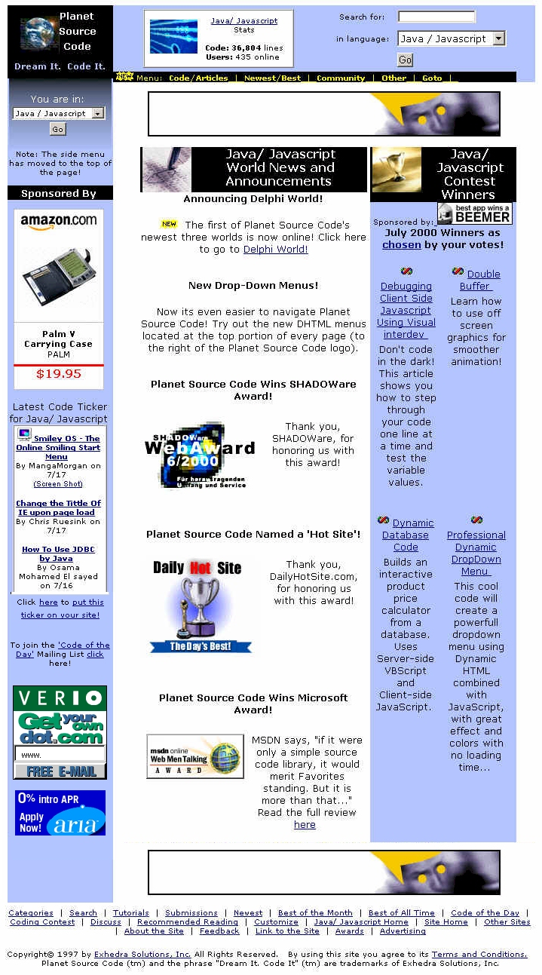  (see sample on next page)

Planet Source Code’s “Code of the Day” Sample:

************************************************
Learn a little more about Visual Basic
each day, with www.Planet-Source-Code.com 's
Code of the Day!

Current # of subscribers: 12,382

Code of the Day:
1) Common Dialog API calls

Submissions Since Yesterday:
2) WebServer
3) MsgBox Maker v2.0
4) live wire v1 BETA 3 new look and fixed bugs <b>Must See</b>
5) A New Screen Saver Lookalike!!!
6) Expand files
================================================
================================================
Create Windows help files with the ease of
point and click, without having to mortgage
your house to do it! Get your free download of
award winning Help Maker Plus today!!
http://www.exhedra.com/vb/default.asp?intAdId=77&lngWId=1
================================================
================================================

1)Common Dialog API calls

Category: Windows API Call/ Explanation
Level: Unknown

Description: Here are the Windows API calls for the ShowOpen, ShowSave,
ShowPrinter, ShowColor and ShowFont (Thanks to Jaen Saul aka SlowByte for his post) dialogs. Also included is the beginnings of the ShowFonts dialog but I am having some trouble getting it to work. These calls are more difficult to use than the CommonDialog control placed on a form, but don't have the version conflicts that Early-Bound and Form-Bound ActiveX controls have. In addition, I have added the ability to center the dialog on the form or center it on the screen.

Complete source code is at:
http://www.planet-source-code.com/vb/default.asp?lngCId=3592&lngWId=1

